The musical instrument

“The Cat Choir”
By Kira Taaffe
Student number: C23380503

This cat choir is a fun and interactive game for toddlers. It features many different cat sounds and meows and has hand drawn buttons. The code contains arrays and if statements. This game design document will show the stages of creating this game.

The beginning:

I began by writing ideas down on paper. I knew I wanted this game to be interactive and fun but also unique in its concept. I had originally planned to make the game using different alien shooting effects but felt that this wouldn’t appeal to you audiences. I went back to the drawing board and finally settled on cats.

However, I had to find a way to make this game interactive and fun, and I began the tedious process of designing and creating the concept of my game.
The original concept was going to involve paw print buttons with cat noises. However, I felt that this would not only look poor, but wouldn’t appeal to the audience I was hoping to make this for. I ended up scrapping the original concept art I had for the paws and began messing around with different cat faces. I eventually got into the flow of the idea and settled on “The Cat Choir”

The process:

The first thing I had to do was to create the button images. I began exploring shapes, colours and many different colour palettes. I also had to look for suitable audios to include in the game.
Using Clip Studio Art, Photoshop and Godot, I began to put the game together. I first drew each cat image separately. These images were to represent a different meow type and sound.
There are seven different sounds in the game, and I had to make sure each cat looked unique. I began with the classic orange cat. His face shape was modelled on a squashed oval. His eyes were flattened to make him appear like he didn’t have a care in the world (see image below).
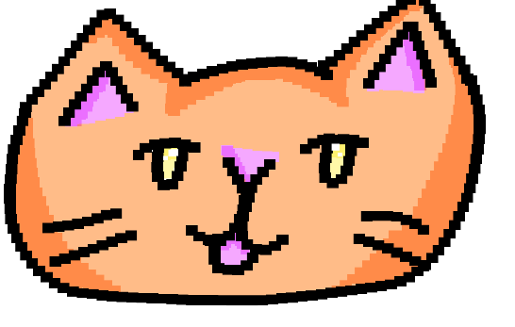
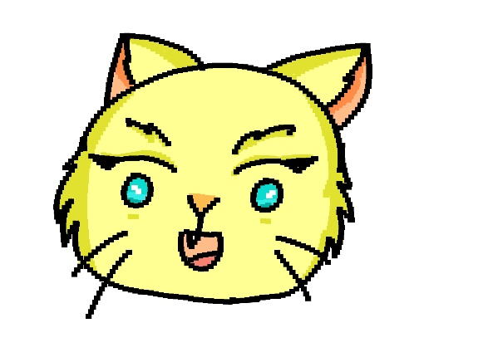
The orange cat was to represent the typical cat meow. I used shades of orange with complementary yellows to make him pop. I then made a yellow cat, who’s meow was high and squeaky. Her face was puffy and cute. (see below)

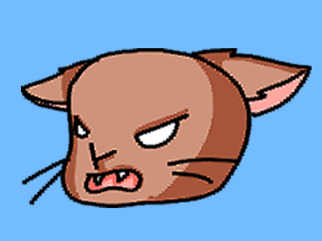
Then, we had the brown cat. The brown cat’s audio was a hiss. His button image also displays this as we can see him baring his teeth with his ears folded back. His face is contorted with rage. (see below)

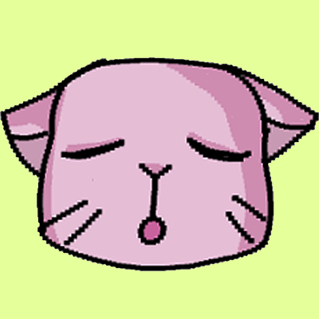
We then had four uniquely coloured cats; a red cat, a green cat, a sage cat and a pink cat. Each of these cats had a unique audio attached to them. (See images below)

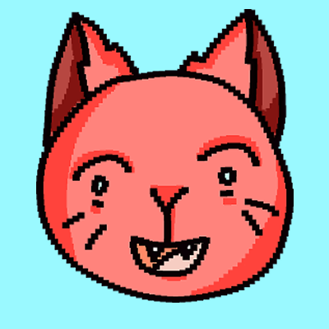

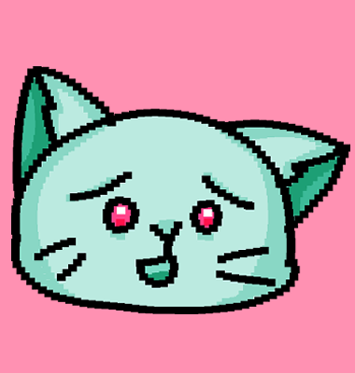

The coding process:
The code was the hardest part of this entire process. It began with me having to learn a new coding language, GD Scripting. This was a new language to me, and it meant I had a lot of googling and research to do.
After many days of research, I managed to come up with a simple code that involved if statements and an array.
The code involved.
onready var meowAudio = $AudioStreamPlayer2D
func _process(delta):
playsound()
func _on_button_button_down():
meowAudio.playing = true
func playsound():
if Input.is_action_just_pressed("meow"):
meowAudio.playing = true

This was the entire code, repeated in one long array. I had to make sure that the button was connected to the correct node and that the AudioStreamer2d was also connected to the button as well as the node. When the code runs, the sound will play when the button is pressed. To make the button work, you simply clock with your mouse cursor.
This was by far the trickiest part of this whole assignment, and it took me a while to get it to work.

The final product:
The final product has all the code, buttons and audios attached to the code. Each button has a unique sound and has a hand drawn image on it. This entire experience was a great learning curve for me and made me more confident in my coding skills.
(see image below of final layout)
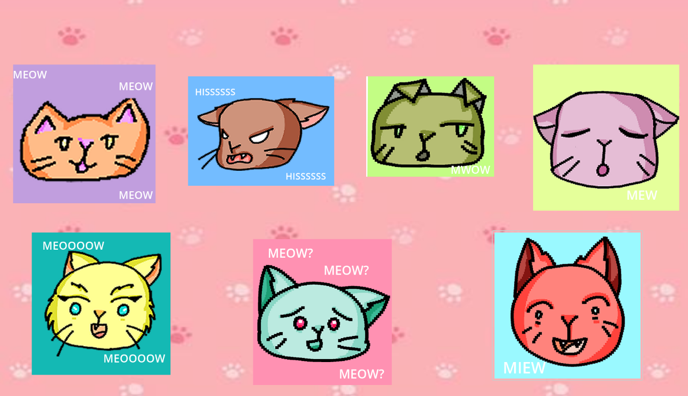

YouTube play demo: https://youtu.be/zdp-xXMNqIU

Sources:
Audio used was from Freesound.org- Url; https://freesound.org/
Background image was from a free photo website- Url; https://www.shutterstock.com/image-vector/seamless-pattern-animal-footprint-on-pink-1510311791
All the artwork is my own. Created on Clip Studio Art.

